**Arya Babu**

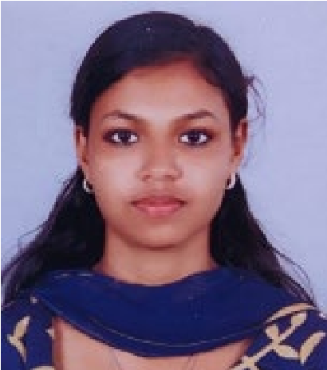

NAD Quarters, Ayudh Vihar, Kalamassery, 683563 [arya.babu9633@gmail.com](mailto:arya.babu9633@gmail.com)

8075203611

# Seeking a role within an organization where I can earnestly discharge my duties and leverage my skills to effectively contribute to the attainment of the company's goals

# Academic Qualifications

* Post graduation in Commerce (M.com Finance and Taxation) in 2024
* Qualified CMA Intermediate from The Institute of Cost Accountants of India in 2021
* Graduation in Commerce (B.com Finance and Taxation) from Sacred Heart College, Thevara in 2020 with A+ grade.
* Higher secondary from Board of Higher secondary, Kerala in 2017 with 98% in Commerce stream
* Secondary (SSLC) from Board of Public examination, Kerala in 2015 with 98%
* Certificate course in Information Technology from The Institute of Cost Accountants of India

# Experience

* ACCOUNTS TRAINEE (May 2022-August 2023) – Municipality
* Prepared and processed invoices, payments and bank deposits.
* Reconciled expenses and financial records
* Reviewed numerical data to ensure accuracy and appropriate categorization
* Reconciled bank statements and resolved discrepancies to ensure accurate financial reporting.
* Assisted in accounts receivable, payable and general ledger activities
* Completed day to day duties accurately and efficiently.
* ACCOUNTS INTERN (MAY To JUNE 2019) – KEL Ltd
* Analysed financial statements to identify trends and make recommendations for improvement
* Identified opportunities for cost savings within the organisation’s operations
* Inspected production, quality control and maintenance report to detect and address production problems

# Skills

* Microsoft Word mastery
* Excel Functions and Formulas Expertise
* Tally ERP 9
* Cost Management
* Excellent Communication in English, Hindi, and Malayalam

# Declaration

I do hereby declare that the above information is true to the best of my knowledge.

Arya Babu